

Team Logo/Graphics

IS480 Project Proposal
Ole Football. Friends. Fun.

wonderwoMAN

01.
4/10/2018

Team Members:
- Hani ‘Aiman binte Mohamed Ishak (haniaimani.2016@sis.smu.edu.sg) – Project Manager
- Nur Hazirah Binte Haris (nurhazirahh.2016@sis.smu.edu.sg) – Back-end Developer
- Nurfarihin Binte Kamaruzzaman (nurfarihink.2016@sis.smu.edu.sg) – System Architect
- Liao Yi-ting (yt.liao.2016@sis.smu.edu.sg) – Front-end Developer
- Sai Sravani Lanka (sravanil.2016@sis.smu.edu.sg) – Quality Assurance
- Li Wei En (weien.li.2016@sis.smu.edu.sg) – Back-end Developer

Faculty Supervisor:
- Name

Sponsor and/or Clients (if any):
- Vishal Kanwar (vishalsk3@gmail.com)
- Bobby Harjani (bobby.harjani@gmail.com)
- Caleb Raj (mrcalebraj@gmail.com)
- Nizam (nizam2604@gmail.com)

Project Overview

Project Description:
Ole Football. Friends. Fun. is an Android mobile application that allows users to predict football scores for different football leagues that is currently ongoing. There will be two main features of the application, which are 1) Private and 2) Public. Private allows users to create a group among their friends and predict the match scores and other additional predictions (i.e: specials) within the group. Public on the other hand allows users to predict the match score and other additional prediction on a public level. The team will be building a web application on top of the mobile application to enable to Admin of the application (i.e: sponsors) to manage the application. Given how niche the concept of the application, the X-factor of the project is to gather 500 testers for our UAT.

Motivation:
Ole Football. Friends. Fun. is an application that aims to gather football fans from all over the world to meet on a common platform under the same interest – football. The concept of the application is different from betting as it strictly does not involve money. Ole Football. Friends. Fun. do not want to encourage betting among youths as young as 15 years old, who falls under the target audience of the application, and instead, would like to provide an alternative to monetary rewards such as prizes.

Stakeholders:
Sponsor | The project was initiated by Vishal Kanwar and Bobby Harjani – an SMU SIS Alumni. The project was posted on IS480 Wiki page and wonderwoMAN approached them to pursue the project.
User | Users for the mobile application are not limited to family and friends but extends to football fanatics who enjoys predicting football scores for different leagues such as the English Premier League and World Cup. The users range from as young as 15 years old to 60 years old and is tech-savvy. The users are not limited to males.  Users for the web application are the Ole Football. Friends. Fun team which includes Vishal, Bobby, Caleb and Nizam.

Deliverables:
Outcomes: The outcomes of the project are 1) an Android mobile application available on Google Play and, 2) a live web-application that allows the administrators (i.e: sponsor) to monitor the mobile application.
Value Statement: What does the sponsor get out of this?

Scope:
Place the priority scope in the following format. This example is from team Carpe Diem.
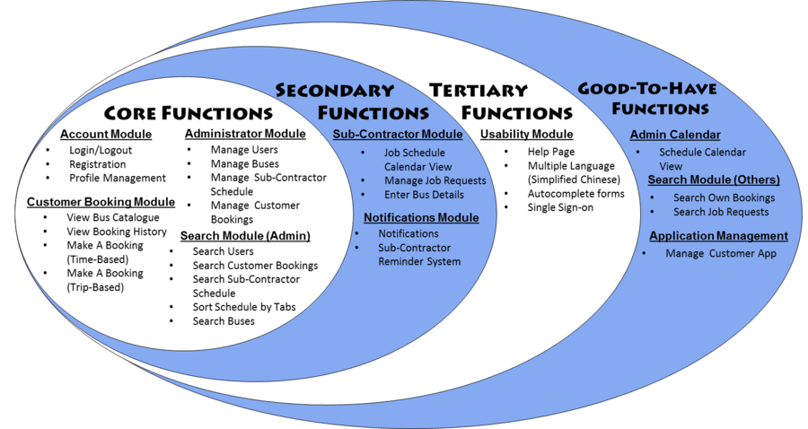
Briefly explain the scope, constraints and assumptions here.

List the functions; storyboard, use case diagram, process diagram, UI mockup/paper prototype, design diagram in the IS480 wiki. Use the diagrams only if it helps explain the scope. Use architecture diagram if necessary to show interface to 3rd party tools/frameworks, existing system API, concurrent team dependencies, etc.

Project Plan
This plan describes the resource, schedule and major risks. The plan provides a basic execution description of the project based on current knowledge of the project.

Project milestone:
Define the work breakdown structure with key milestones. Use a project timeline.
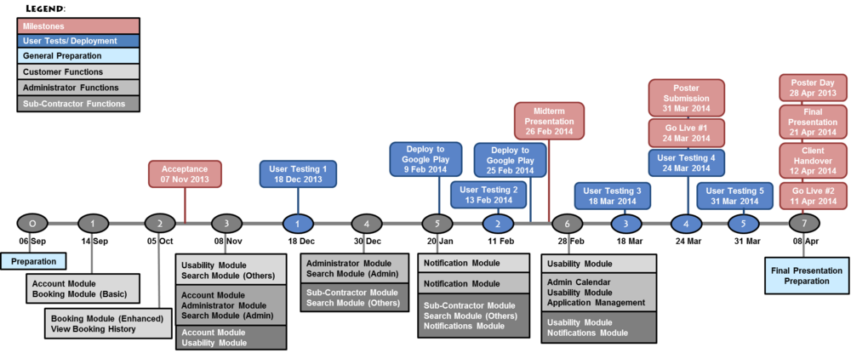
Define the iteration breakdown with functions/features list and user testing. List specific dates for your milestones! You should plan to demo your system during project acceptance, midterm and finals, include user testing, deployment and releases. Each milestone should have clear goals/functions. Note that each module should map to the priority scope

Risks:
Identify assumptions and risks particular to this project, stakeholders, schedule, team, technology constraints, etc. Do not put generic risk, such as “requirement may change”, unless it is specific to the sponsor. List mitigation steps.

- Project might go slower at the start because members are not used to android programming and will take some time to get used to it. Which may delay the start of the development for the application.
  - 1 backend programmer can focus on the web admin application first.
  - The other 2 focus on the android mobile application.

Resource and reference:
What do you need? Training on programming (list books, web pages, hardware, software, gadgets, contact, client time, tester time, supervisor time, training course, money, trips), etc. Described the technology that you will be using (programming language, frameworks, APIs, platforms, OS, etc).

At the beginning of the project the team would require training in android programming. We will make use of the recess week to do this.

The technology that we will be using is as follows:
- Web Admin Portal
  - JSP, Java on Netbeans
- Android Mobile Application
  - Java using Android Studio
- Database
  - MySQL
- APIs

- Deployment
  - We will be deploying the app on AWS. Cost:
  - Application will be placed on Google Play Store. Costs:

Learning outcome:
The team is responsible for defining the learning object in the IS480 team wiki pages. This section is not required in this proposal.

Team without a name will be given a horrible name such as NoName1 and you will not be able to change your team name.
To be assigned by course coordinator

